PROJECT REPORT

- INTRODUCTION:

  - Project Overview:
According to the World Health Organization (WHO), cardiovascular diseases (CVDs) are the number one cause of death today. Over 17.7 million people died from CVDs in the year 2017 all over the world which is about 31% of all deaths, and over 75% of these deaths occur in low and middle-income countries. Arrhythmia is a representative type of CVD that refers to any irregular change from the normal heart rhythms. There are several types of arrhythmias including atrial fibrillation, premature contraction, ventricular fibrillation, and tachycardia. Although a single arrhythmia heartbeat may not have a serious impact on life, continuous arrhythmia beats can result in fatal circumstances. In this project, we build an effective electrocardiogram (ECG) arrhythmia classification method using a convolutional neural network (CNN), in which we classify ECG into seven categories, one being normal and the other six being different types of arrhythmias using deep two-dimensional CNN with grayscale ECG images. We are creating a web application where the user selects the image which is to be classified. The image is fed into the model that is trained and the cited class will be displayed on the webpage.
  - Purpose:
In this project, we intend to develop a web interface that is capable of predicting the type of Arrhythmia, that a person is diagnosed with, based on the ECG image given to the interface by the user. This project will be useful for people who are at high-risks of getting diagnosed with heart ailments, and by using this application, they might be able to undertake necessary preventive measures to tackle the ailment at the earliest. We have made the interface as smooth and as user-friendly as possible, and we have removed several bloatware that take up space and hinder the performance. For the prediction, we are using a custom Convolutional Neural Network Model with 2 million trainable parameters, that yields an accuracy of over 98%.

- LITERATURE SURVEY

  - Existing Problem:
In the existing methods proposed for Arrhythmia classification the techniques used for ECG denoising, Feature Extraction and Classification can be improved. ECG pre-processing methods are not discussed in detailed fashion, in some papers. The variability of other ECG waves, such as P waves, and T waves could be studied based on the proposed feature extraction algorithm to further improve the performance of the whole system. Also, in a few papers, Support-Vector -Machine algorithm is used, which is inefficient when compared to Artificial Neural Networks. In summary, the techniques discussed in the existing methods are quite outdated.
  - References:
1. Mohebbanaaz, Y. P. Sai and L. V. R. kumari, "A Review on Arrhythmia Classification Using ECG Signals," 2020 IEEE International Students' Conference on Electrical,Electronics and Computer Science (SCEECS), 2020, pp. 1-6, doi: 10.1109/SCEECS48394.2020.9.
2. J. Lang and F. Yang, "An improved classification method for arrhythmia electrocardiogram dataset," 2019 IEEE 2nd International Conference on Information Communication and Signal Processing (ICICSP), 2019, pp. 338-341, doi: 10.1109/ICICSP48821.2019.8958499.
3. H. Yang and Z. Wei, "Arrhythmia Recognition and Classification Using Combined Parametric and Visual Pattern Features of ECG Morphology," in IEEE Access, vol. 8, pp. 47103-47117, 2020, doi: 10.1109/ACCESS.2020.2979256.
4. P. Varalakshmi and A. P. Sankaran, "Classification of Arrhythmia Based on Machine Learning Algorithms Using ECG Signals," 2022 International Conference on Advances in Computing, Communication and Applied Informatics (ACCAI), 2022, pp. 1-7, doi: 10.1109/ACCAI53970.2022.9752565.
5. C. Ye, M. T. Coimbra and B. V. K. Vijaya Kumar, "Arrhythmia detection and classification using morphological and dynamic features of ECG signals," 2010 Annual International Conference of the IEEE Engineering in Medicine and Biology, 2010, pp. 1918-1921, doi: 10.1109/IEMBS.2010.5627645.

  - Problem Statement Definition:
In this project, an effective electrocardiogram (ECG) arrhythmia classification method using a convolutional neural network (CNN) needs to be built, in which ECG images are to be classified into seven categories, one being normal and the other six being different types of arrhythmias using deep two-dimensional CNN with grayscale ECG images. Later, a web application is created, where the user selects the image which is to be classified. The image is fed into the model that is trained and the cited class should be displayed on the webpage.

- IDEATION AND PROPOSED SOLUTION:
  - Empathy Map Canvas
  - Ideation and Brainstorming
  - Proposed Solution
1. Problem Statement (Problem to be solved):
To create a Deep Learning Model that classifies various types of Arryhythmia with 2-
dimensional ECG Spectral Image representation.
2. Idea / Solution Description
In the pre-processing phase - the electromyographic noise present in the ECG signals are
removed using wavelet based thresholding technique. Next the ECG signal is transformed into a 2-D representation using a 2D CNN Model. In order to perform this transformation, an efficient CNN model is implemented after analysing various architectures. The core idea is to make this CNN model classify different kinds of arrhythmia such as LBB, PVC, RBB etc.
3. Novelty / Uniqueness
We will attempt to create an API that is capable of handling inputs and producing the
corresponding Arrhythmia class for the given ECG signal. This API will help to simulate an
interactive user environment for gaining a seamless experience.
4. Social Impact / Customer Satisfaction:
The major stakeholders of this project are the individuals aged more than 50. By getting
to know about irregularities in the ECG signals of heartbeats, customers can greatly benefit from early diagnosis of heart ailments.
5. Business model / Revenue Model:
There isn't a single application out there in the market that performs detection of
Arrhythmia. By integrating our novel product with a smart wearable, we can launch a new series of health tracking smart devices.
6. Scalability of the solution:
By pitching our idea to Angel Investors and Venture Captialists, we can extend this idea
into a reality by launching a fully-fledged startup that markets this product.

  - Problem Solution Fit:
- REQUIREMENT ANALYSIS

  - Functional Requirement:

Following are the functional requirements of the proposed solution.

FR No. | Functional Requirement (Epic) | Sub Requirement (Story / Sub-Task)
FR-1 | User Registration | Registration through Form  Registration through Gmail  Registration through LinkedIN
FR-2 | User Confirmation | Confirmation via Email  Confirmation via OTP
FR-3 | User selection | Knowledge about ECG images select the image to be classified
FR-4 | User input | Images need to be uploaded
FR-5 | Save image | Images are saved in uploaded folder
FR-6 | Predict ECG image | User ECG images in our web application Collection of data sets Database read ECG images

  - Non-Functional Requirement:
Following are the non-functional requirements of the proposed solution.

FR No. | Non-Functional Requirement | Description
NFR-1 | Usability | A user friendly and simple UI Web application. Easy drag and drop options
NFR-2 | Security | No third-party web and UI is used for prediction of data Details about user interaction with the web application are protected
NFR-3 | Reliability | Higher accuracy rate  Defect free
NFR-4 | Performance | Fast and quick classification of the required class is done
NFR-5 | Availability | Availability describes how likely the system is accessible to a user at a given point in time and the periodically for a solution.
NFR-6 | Scalability | The ability of the user problem in arrhythmia disease to handle an increase in workload without performance degradation

- PROJECT DESIGN

  - Data Flow Diagrams:

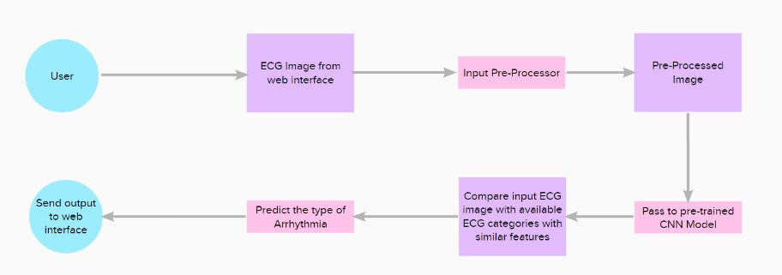

  - Solution and Technical Architecture:
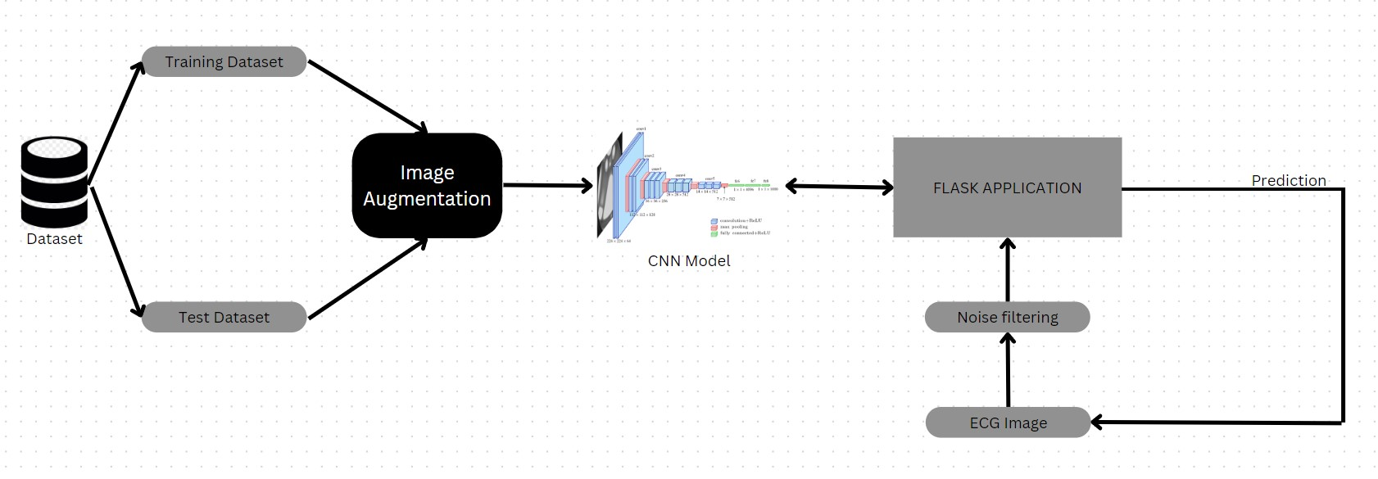
  - User Stories:

User Type | Functional Requirement (Epic) | User Story Number | User Story / Task | Acceptance criteria | Priority | Release
Patient/Doctor  (Web User) | Web interface | USN-1 | As a user, I can access the web interface | I can login to my account | High | Sprint-1
Patient/Doctor  (Web User) | Dashboard | USN-2 | As a user, I can access the dashboard/homepage | I can view the homepage | High | Sprint-1
Patient/Doctor  (Web User) | Types of Arrhythmias | USN-3 | As a user, I can view various articles about different kinds of Arrhythmia | I can view the articles | Low | Sprint-1
Patient/Doctor  (Web User) | Page Navigation | USN-4 | As a user, I can access several tabs and pages on the interface | I can view different pages and navigate | Medium | Sprint-2
Patient/Doctor  (Web User) | Info and About Page | USN-5 | As a user, I can see the info and about page for the web interface | I can view the info and about page | Medium | Sprint-2
Patient/Doctor  (Web User) | Page to send input | USN-6 | As a user, I can see an option to upload input image of ECG | I can view the input page | High | Sprint-3
Patient/Doctor  (Web User) | Prediction result page | USN-7 | As a user, I can see the predicted result for the given ECG image | I can view the prediction | High | Sprint-3
Patient/Doctor  (Web User) | Type of Arrhythmia | USN-8 | As a user, I can see the type of Arrhythmia | I can view the type of Arrhythmia page | High | Sprint-3
Patient/Doctor  (Web User) | Side-effects page | USN-9 | As a user, I can see the various side effects of the predicted Arrhythmia | I can view the side effects page | Low | Sprint-4
Patient/Doctor  (Web User) | Prediction history page | USN-10 | As a user, I can see the various predictions done in the past | I can view the prediction history page | Medium | Sprint-4
Patient/Doctor  (Web User) | Type of CVD page | USN-11 | As a user, I can see the predicted type of CVD based on predicted arrhythmia | I can view the type of CVD page | High | Sprint-4
Administrator | Performance metrics | USN-12 | As an administrator, I can see the number of people who are using the developed interface | I can view the performance metrics | Medium | Sprint-4

